**STAT 614 - HW 3**

**By Sihyuan Han**

1. Triceps skinfold thickness is an upper arm measurement that has been used as a proxy measure of body fat. The table below gives the mean and standard deviations of tricep skinfold thickness (in cm) for two populations of adult males, those with chronic airflow limitation (such as COPD, a type of obstructive lung disease) and those without any airflow limitation. A study comparing tricep skinfold thickness is being planned in these populations using the respective sample sizes (*n*), also given in the last column of the table.

|  |  |  |  |
| --- | --- | --- | --- |
| Population | 𝜇 | 𝜎 | *n* |
| Chronic airflow limitation | 0.92 | 0.4 | 32 |
| No airflow limitation | 1.35 | 0.5 | 40 |

* + 1. Consider a random sample 𝑦1, 𝑦2, 𝑦3, … , 𝑦𝑛 from the chronic airflow limitation population with mean 𝜇 and standard deviation 𝜎 as given in the table. What is the standard deviation of the sample mean, 𝑦̅? (Note, this is often called the “standard error” of the mean, especially when an estimate for 𝜎 is used.)

**Ans**: SE= 𝜎/sqrt(n)= 0.4/ sqrt(32)= **0.07071068**

* + 1. Assume the Central Limit Theorem is applicable. What does it suggest about potential values of the sample mean, 𝑦̅, the researchers can expect in their study?

**Ans**: if we continued to take many independent random samples from the chronic airflow limitation population and compute the 𝜇 and 𝜎 it will show as normal distribution based on Central Limit Theorem.

1. A human resources manager for a large company takes a random sample of 50 employees from the company database. She calculates the mean time that they have been employed. She records this value and then repeats the process: She takes another random sample of 50 names and calculates the mean employment time. After she has done this 1000 times, she makes a histogram of the mean employment times. Is this histogram a display of the population distribution, the distribution of a sample, or the sampling distribution of mean?

**Ans**: According to Central Limit Theorem, this is **sampling distribution of mean**, because it is the distribution of the mean based on 1000 times of random samples.

1. In most software, the default p-values are computed based on a 2-sided alternative hypothesis (HA: *μ ≠ μ0*). However, we may want to use a 1-sided alternative in some problems. Hence, we need to be able to compute the correct 1-sided p-values from the reported 2-sided version. Sketch a graph for each of the following to demonstrate that each is the correct procedure. (You can take a photo of your sketch to include in your HW.)

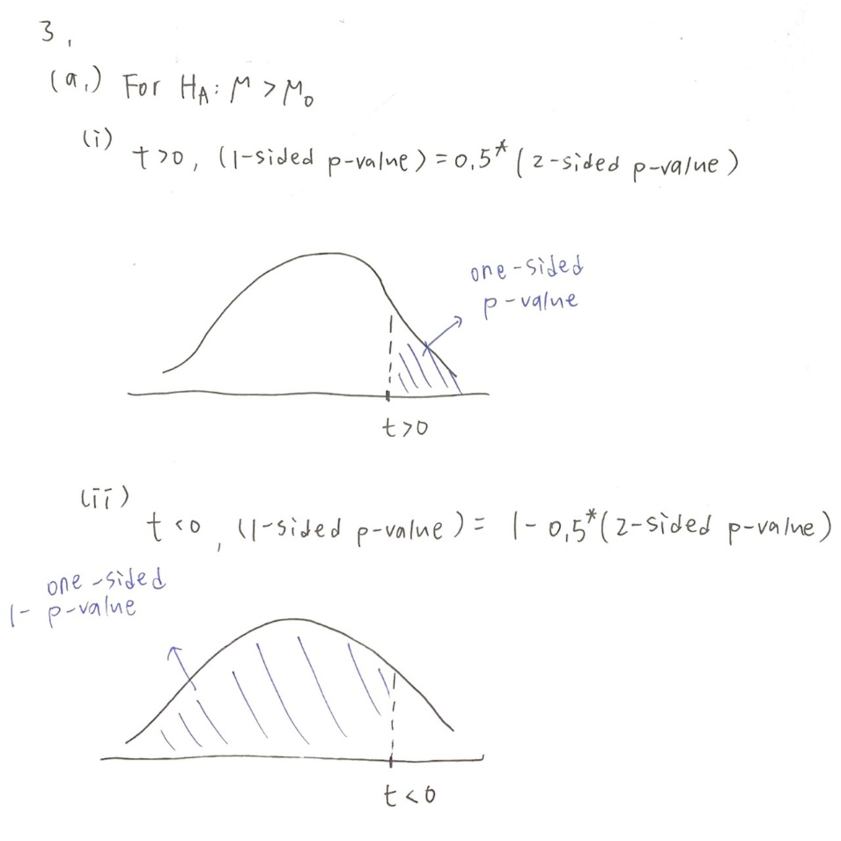

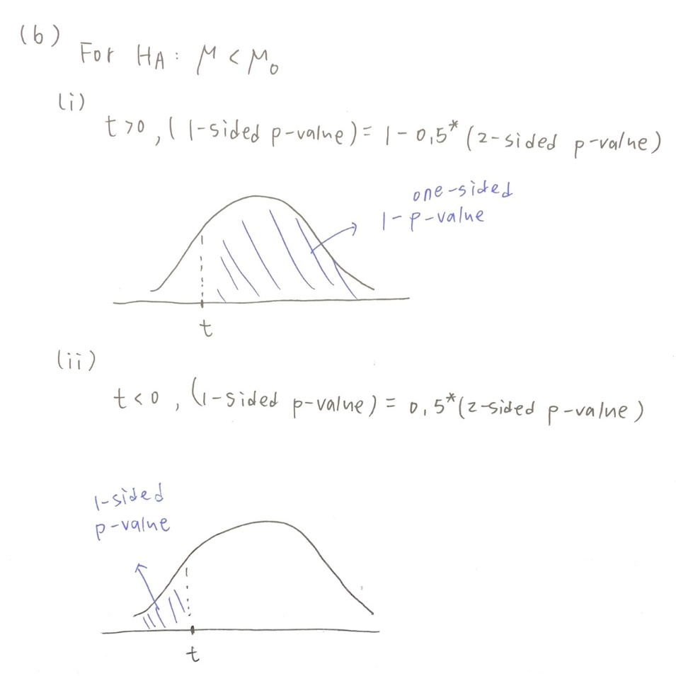

1. Suppose the following statement is made in the conclusions section of a paper: "A comparison of breathing capacities of individuals in households with low nitrogen dioxide levels and individuals in households with high nitrogen dioxide levels indicated that there is **no difference** in means (two-sided p-value = 0.24)."

* 1. Give a reasonable null and alternative hypothesis that was being tested in this scenario.

Carefully define the population parameters of interest being tested.

**Ans**: null hypothesis: mean of low nitrogen = mean of high nitrogen

alternative hypothesis: mean of low nitrogen ≠ mean of high nitrogen

* 1. Why is this statement an inaccurate summary of the hypothesis test?

**Ans**: p-value = 0.24 >0.05, null hypothesis should not be rejected, but it doesn’t mean that there’s no difference between the groups, it only shows that no difference was found in the study

* 1. Re-write the statement so that it is properly summarizing the results of the hypothesis test.

**Ans:** "A comparison of breathing capacities of individuals in households with low nitrogen dioxide levels and individuals in households with high nitrogen dioxide levels indicated that there is **no difference was found** in means (two-sided p-value = 0.24)."

1. **Use the lead.csv data set from HW 1.** Revisit HW 1 for a description of this data set and study. For this problem you will compare the Wechsler full-scale IQ scores (the variable IQF) between the different lead exposure groups, denoted by the GROUP variable.

* 1. Compute the mean, standard deviation, standard error, and 95% confidence interval for the population mean IQ score for **each** lead exposure group, separately. Summarize each confidence interval.

**Ans**:

Group1

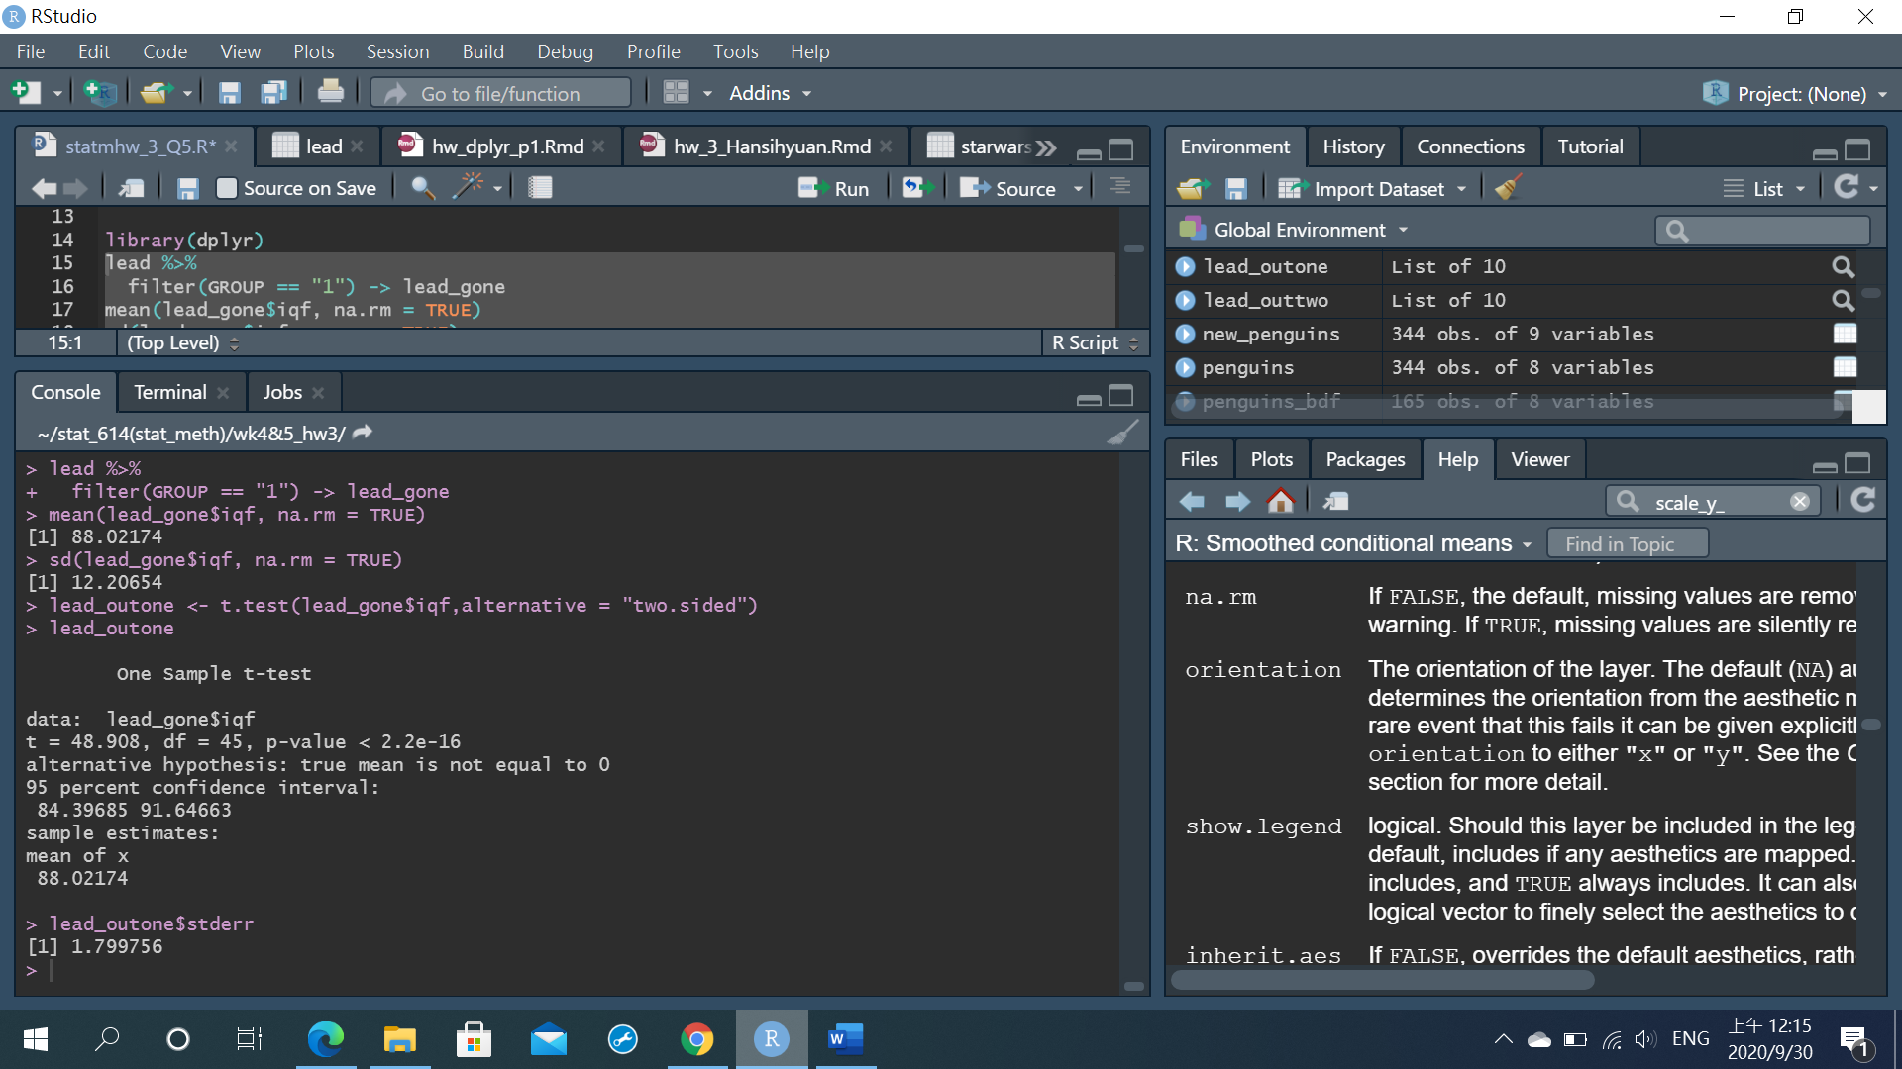

It suggests that gruop1 people has mean IQ score between 84.39685 to 91.64663, 95% on average.

Group2



It suggests that gruop2 people has mean IQ score between 89.42496 to 96.34427, 95% on average.

* 1. Researchers were interested in assessing the difference in the mean IQ score between the two exposure group populations. Give the estimate mean difference, the standard error, and the 95% confidence interval for the **difference** in population mean IQ scores. Summarize the confidence interval.

**Ans**:



null hypothesis: mean IQ score GROUP2 = GROUP1

alternative hypothesis: mean IQ score GROUP2 ≠ GROUP

mean difference= 92.88- 88.02= 4.86

standard error= 2.501552

p-value= 0.05442 >0.05, null hypothesis unlikely to be rejected

so we cannot states that different blood lead levels will affect IQ score

* 1. Researchers hypothesized that the exposed group (GROUP = 1) would have a lower population mean IQ score than the control group (GROUP = 2). Set up and conduct a statistical hypothesis test to address the research hypothesis. Carefully state the null and alternative hypotheses to be tested. Give the parameter of interest, the estimate of this parameter, the standard error of the estimate, the test statistic, and the p-value. Summarize the results of the test.

**Ans**:



null hypothesis: mean IQ score GROUP2 ≤ GROUP1

alternative hypothesis: mean IQ score GROUP2 > GROUP1

Par= 111.41

Est= 92.88- 88.02= 4.86

SE= 2.501552

test statistic= 1.94

p-value= 0.027 <0.05: there is evidence to reject the null hypothesis, there is 95% CI for group1’s mean IQ score is less than group2’s mean IQ score, so blood-lead levels > 40 mg/ml(group1) has lower mean IQ score than blood-lead levels > 40 mg/ml(group2) (95% CI)